Bryan Guner

2/11/14

**Team Members:** Hailey Scott, Trevor Osler, Nikita Eisenhauer

Golf Ball Tower

(Design and Communication exercise)

The golf ball tower was a simulation of the conditions under which Engineers are expected to work. Disguised as an exercise in design, the real challenge was communicating with a randomly assigned group of peers under logistical and time constraints in order to produce a working solution on the spot. Once our team gathered at the station, I tried to take charge of the project in order to make sure our efforts were consolidated. While the assignment was being explained, I got a little carried away and began sketching an overly elaborate design as seen in *figure 1* (top sketch). Unfortunately, I tend to be overly ambitious when taking on a creative project, hence the necessity for a well-rounded group dynamic.

Hailey had to be the voice of reason, pointing out that not only did we not have enough tape and paper to build my design, but we also lacked the time to plan and construct it. She ended up taking the role of arbiter pointing out when an idea was practical and when an alternative solution would be necessary. Her realism combined laid back personality kept the group focused on trying to produce a practical solution. Of all the members of the group, Trevor was the most aware of the impending timeline, and made it clear that starting construction was just as important as developing a workable solution. He made the case that no matter how elegant the design at the end of the period; a sketch could not hold a golf ball 30 inches off the ground. His pragmatism gave way to Nikita’s design, which entailed rolling paper long ways and banding together 3 such columns for every level above the base with horizontally cut strips of paper, using 5 columns taped to a 4 by 6 inch paper on the table as the base. The columns used in the design were very similar in size to the column in Trevor’s hand captured in *figure 2*. Trevor also stressed the importance of economizing our resources, specifically, tape, a consideration I dismissed in the excitement of planning the structure that the tape would hold together.

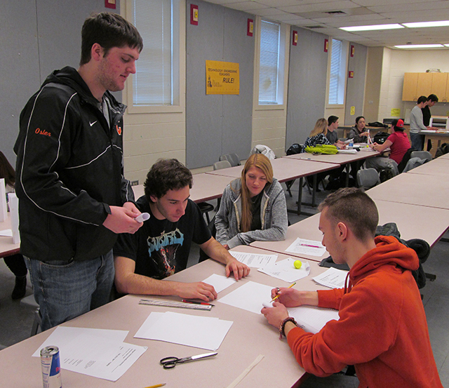

**Figure 2**

(In this photo Trevor can be seen rolling one of the paper columns used in structure)

Nikita was the least opinionated member of the group, working with whatever ideas were thrown his way. The irony of his humble approach was that we ended up constructing his banded-rolled column concept.

The greatest technical issues stemmed from the time in which the golf ball tower had to be designed, agreed upon and constructed. Because of time constraints, our group settled on a design with a relatively small footprint and no supportive trusses even within the allotted square foot base. Because I originally insisted on an elaborate design and held my ground for about half of the class, we completed the design phase around the time most group’s construction was nearing completion. In a panic to produce a tangible structure we attached the levels without carefully centering them or adhering them to each other adequately. As a result the tower was not stable enough to keep the gold ball from rolling off the cap for over a minute. While the tower did not meet the requirements, the group functioned constructively. The only fault in our group dynamic was my own stubbornness. Wile insignificant in daily life, my inability to compromise on the fly demonstrated how strong the correlation between dynamics and success is in the field of engineering.

Where photo of final golfball tower and caption will be inserted when uploaded to TST website

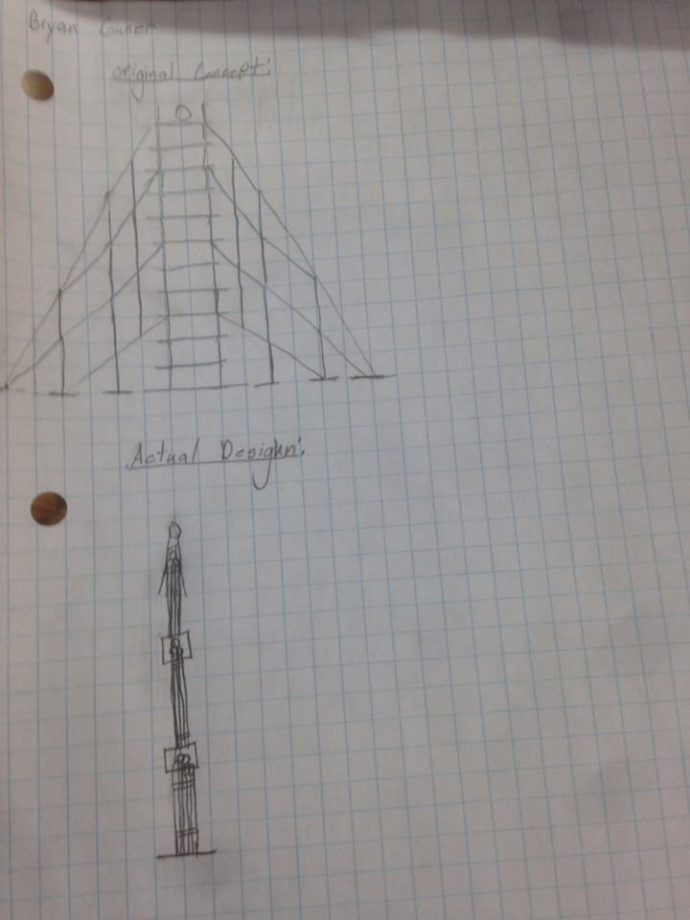

**Figure 1**

*(Original concept and final design sketches, top and bottom respectively)*